Abstract Submission for TRVS XIII

Address of the Presenter/Corresponding Author :

Second_Name:
First Name:
Institution:
Street Address:
City:
Zip:
Country:
Email Address:
Telephone Number:

Title of the Contribution:

Authors

Type of Presentation :

Contributed Oral or Poster Presentation
Poster Presentation only

Copyright Statement:
With the submission of this abstract, the authors agree that the submitted information will be used by the organizers of the conference for various conference purposes including presentation on the web and in a printed/electronic form. The author grants that the submitted abstract is not subject to any copyright.

Note : Length of the abstract should not exceed one page!

Your title in bold 14 pt letters

X. Author¹, Y. Author¹, Z. Author²(Names of all authors in italic 14 pt letters)
¹ Affiliation of first group authors (in 10 pt letters) Department of X, University of Y, 142, Somewhere Street, 12345 Little Town, No man’s land. ² Affiliation of second group of authors (and so on). Please add the e-mail address and URL of the presenter.
Insert the text of your abstract here. The abstract including title, figure, references, etc. must not exceed one page. If available use A4 paper format. Set all margins (left,right,top,buttom) to 2.5 cm. The text should be written in a 12 pt Times New Roman font. Typeset the text in full justification.
Except for the first new paragraphs should start with an indent. References should be cited in “footnote fashion” using a superscript. The references should be typed in a 10 ps Times New Roman font in the format used below.
Please include one figure which in graphical abstract style summarizes your contribution.
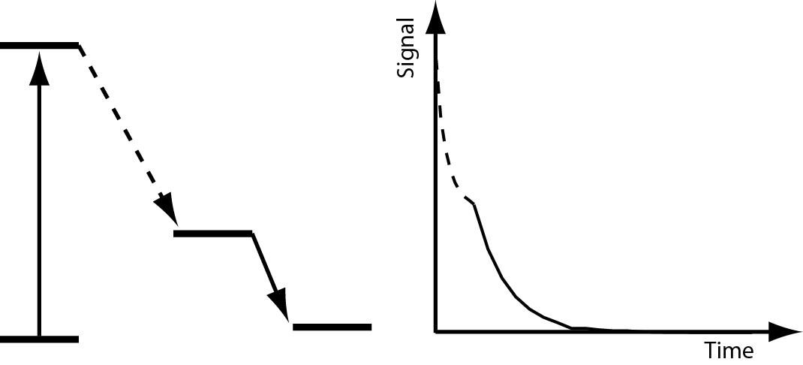
The figure caption should be typed in a 10 pt font size.
Save and submit your contribution as a pdf file.

J.Q. Public, A.B. Miller, J. Appl. Phys., 1989, 11, 109-116
J. Doe, “Introduction into Anything”, Someone’s Publishing House, Everywhere Town, 2004

