Proceedings Submission for TRVS XIII

Address of the Corresponding Author :

Second_Name:
First Name:
Institution:
Street Address:
City:
Zip:
Country:
Email Address:
Telephone Number:

Title of the Contribution:

Authors

Pagenumber of the contribution in the TRVS-Abstract-Book: _____

Copyright Statement:
With the submission of this contribution, the authors grant that the submitted abstract is not subject to any copyright and that the submitted contribution was presented at the TRVS XIII conference. The authors agree that the submitted contribution will be used by the organizers of the conference for the compilation of the proceedings. The authors grant the Munich University Library the right to store the contribution and to make it permanently available publicly for free on-line. The authors declare that the material is their own intellectual property and they understand that the Munich University Library does not assume any responsibility if there is any breach of copyright in distributing these files or metadata.

Note : Length of the paper should be 4 pages for plenary speakers and 3 pages for all other contributions!
Your title in bold 14 pt letters
X. Author1, Y. Author1, Z. Author2(Names of all authors in italic 14 pt letters)
¹ Affiliation of first group authors (in 10 pt letters) Department of X, University of Y, 142, Somewhere Street, 12345 Little Town, No man’s land. ² Affiliation of second group of authors (and so on). Please add the e-mail address and URL of the presenter.
Insert the text of your contribution to the proceedings of the TRVS XIII here. The contribution including title, figure, references, etc. must not exceed three pages (four pages for plenary lecturers). If available use an A4 paper format otherwise use “Letter”. Set all margins (left,right,top,buttom) to 2.5 cm. The text should be written in a 12 pt Times New Roman font. Typeset the text in full justification.
Except for the first new paragraphs should start with an indent. References should be cited in “footnote fashion” using a superscript,. The references should be typed in a 10 pt Times New Roman font in the format used below.
The number of figures in your contribution is not limited. The use of color in the figures is encouraged. We suggest that your first figure summarizes your contribution in graphical abstract style. You may of course “recycle” the figure used in your abstract.
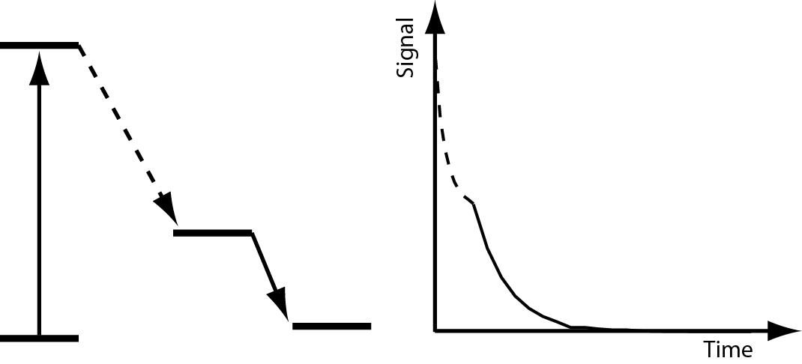
The figure caption should be typed in a 10 pt font size. The figure should span the width of the page.

Save and submit your contribution as a pdf-file. Do not forget to embed the fonts in your file (If you have any doubt about the quality of your pdf-file, please also submit the doc-file). Please send your contribution to
trvsxiii@physik.uni-muenchen.de

The deadline for the submission of your contribution is June 25th, 2007.

The proceedings will be posted on the web server of the LMU München as a searchable document.

J.Q. Public, A.B. Miller, J. Appl. ???, 1989, 11, 109-116
J. Doe, “Introduction into Anything”, Someone’s Publishing House, Everywhere Town, 2004

